LOGADHEEP N

IT - B

727721EUIT082

**CODING CONTEST - I**

**1.**

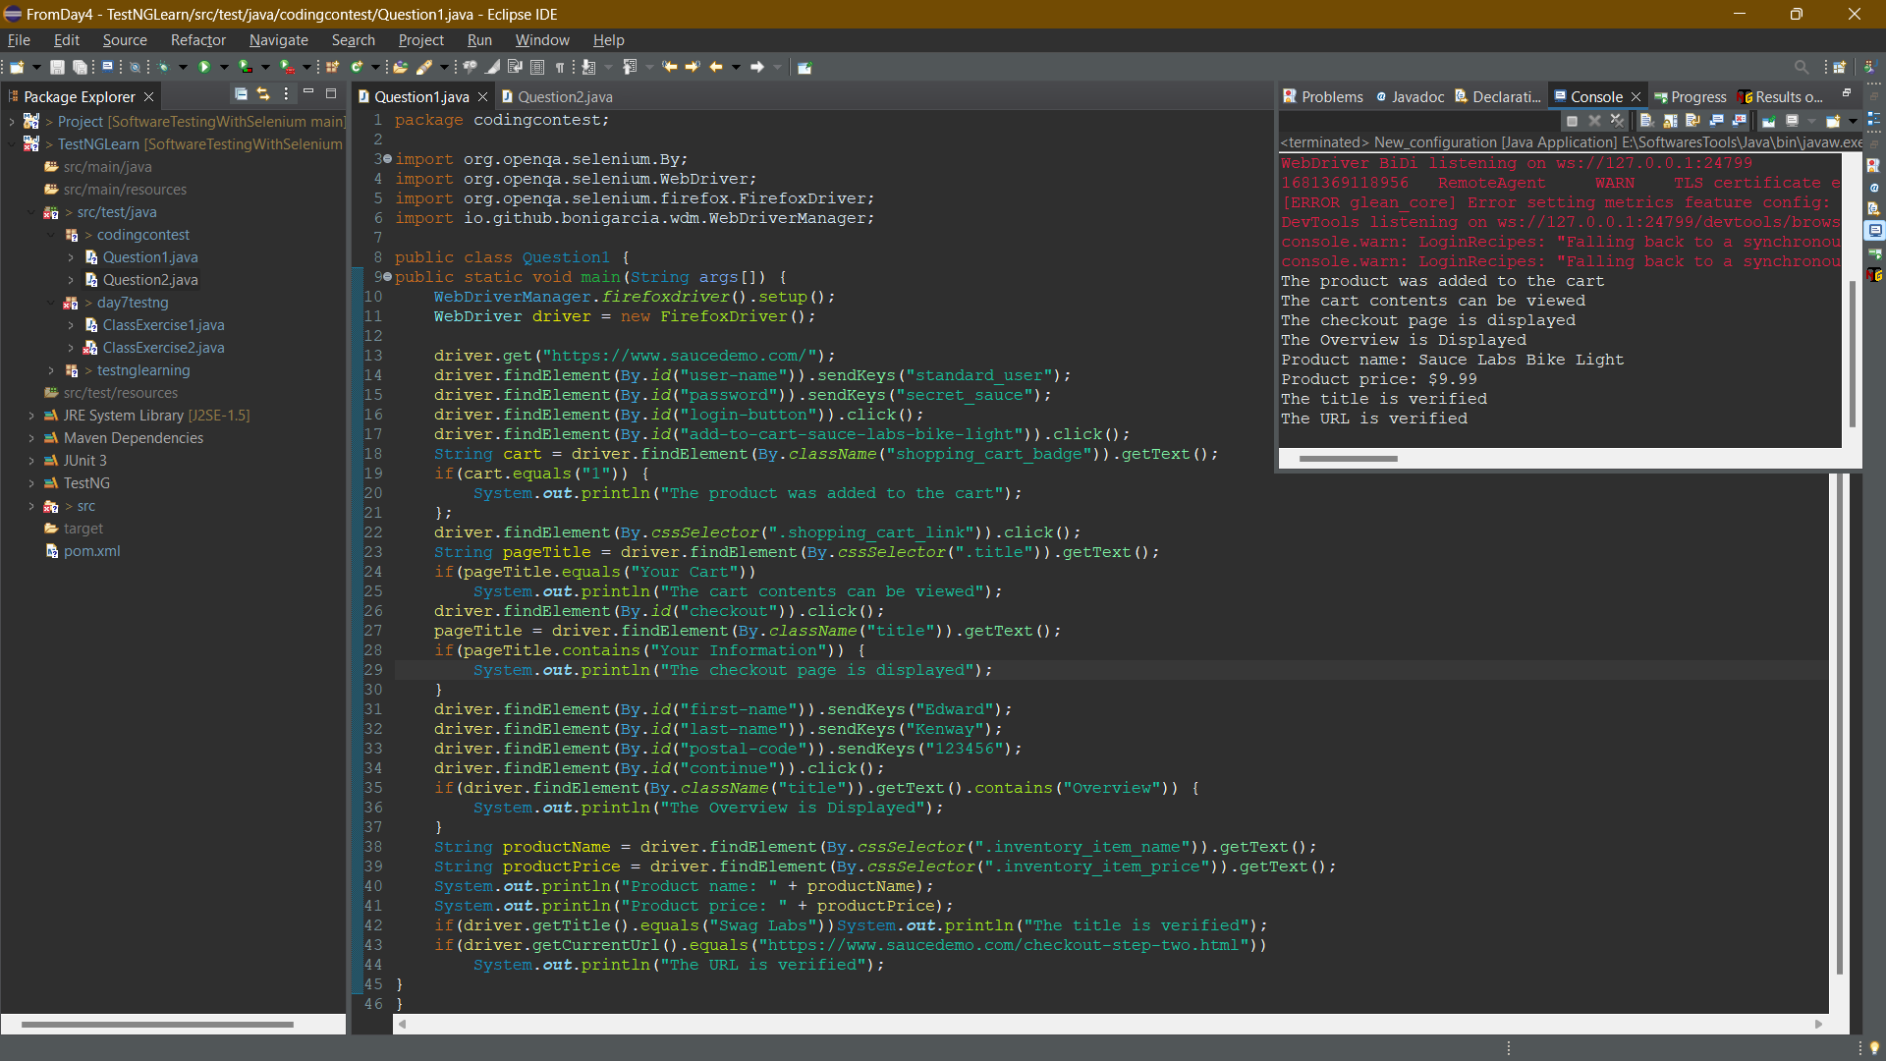

**Coding:**

package codingcontest;

import org.openqa.selenium.By;

import org.openqa.selenium.WebDriver;

import org.openqa.selenium.firefox.FirefoxDriver;

import io.github.bonigarcia.wdm.WebDriverManager;

public class Question1 {

public static void main(String args[]) {

WebDriverManager.firefoxdriver().setup();

WebDriver driver = new FirefoxDriver();

driver.get("https://www.saucedemo.com/");

driver.findElement(By.id("user-name")).sendKeys("standard_user");

driver.findElement(By.id("password")).sendKeys("secret_sauce");

driver.findElement(By.id("login-button")).click();

driver.findElement(By.id("add-to-cart-sauce-labs-bike-light")).click();

String cart = driver.findElement(By.className("shopping_cart_badge")).getText();

if(cart.equals("1")) {

System.out.println("The product was added to the cart");

};

driver.findElement(By.cssSelector(".shopping_cart_link")).click();

String pageTitle = driver.findElement(By.cssSelector(".title")).getText();

if(pageTitle.equals("Your Cart"))

System.out.println("The cart contents can be viewed");

driver.findElement(By.id("checkout")).click();

pageTitle = driver.findElement(By.className("title")).getText();

if(pageTitle.contains("Your Information")) {

System.out.println("The checkout page is displayed");

}

driver.findElement(By.id("first-name")).sendKeys("Edward");

driver.findElement(By.id("last-name")).sendKeys("Kenway");

driver.findElement(By.id("postal-code")).sendKeys("123456");

driver.findElement(By.id("continue")).click();

if(driver.findElement(By.className("title")).getText().contains("Overview")) {

System.out.println("The Overview is Displayed");

}

String productName = driver.findElement(By.cssSelector(".inventory_item_name")).getText();

String productPrice = driver.findElement(By.cssSelector(".inventory_item_price")).getText();

System.out.println("Product name: " + productName);

System.out.println("Product price: " + productPrice);

if(driver.getTitle().equals("Swag Labs"))System.out.println("The title is verified");

if(driver.getCurrentUrl().equals("https://www.saucedemo.com/checkout-step-two.html"))

System.out.println("The URL is verified");

}

}

2.

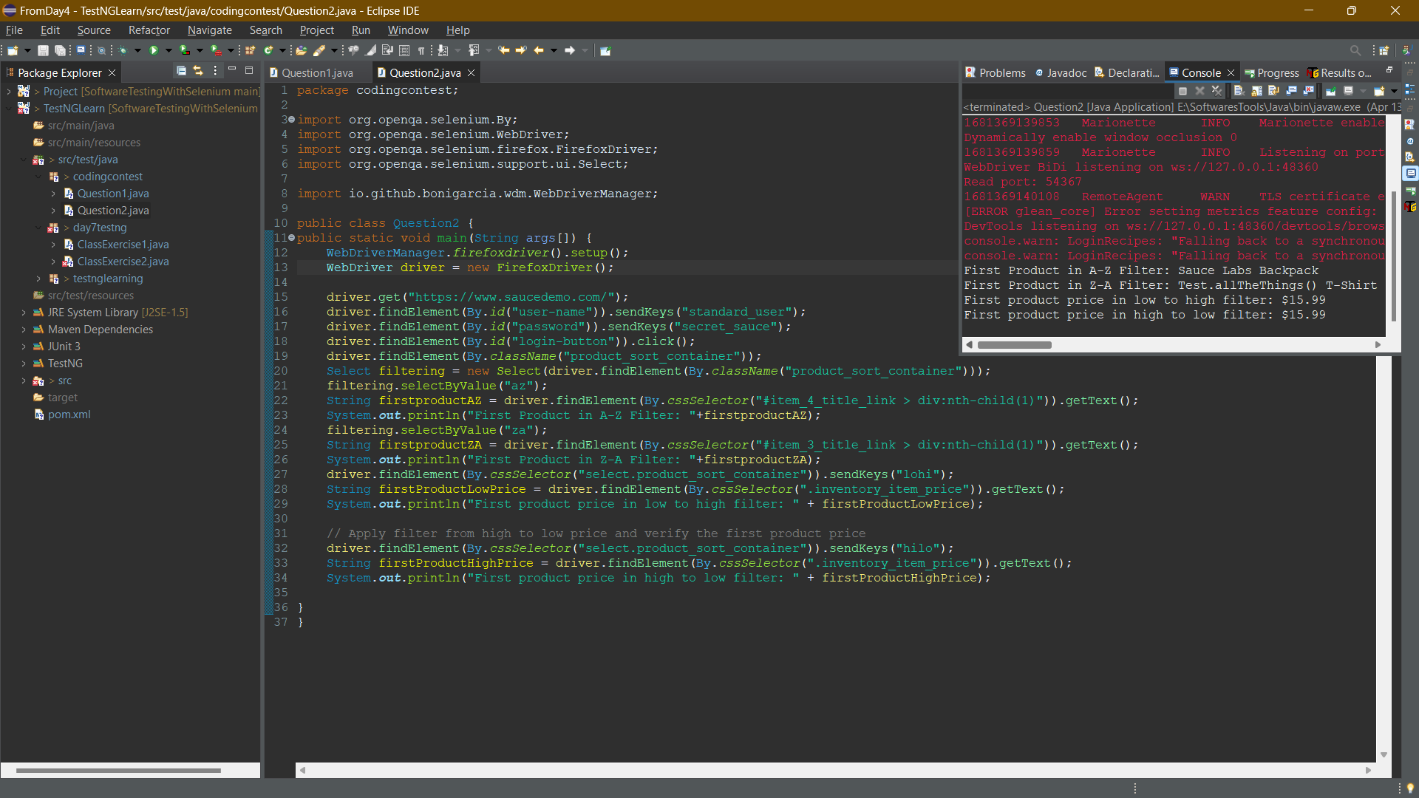

**Coding:**

package codingcontest;

import org.openqa.selenium.By;

import org.openqa.selenium.WebDriver;

import org.openqa.selenium.firefox.FirefoxDriver;

import org.openqa.selenium.support.ui.Select;

import io.github.bonigarcia.wdm.WebDriverManager;

public class Question2 {

public static void main(String args[]) {

WebDriverManager.firefoxdriver().setup();

WebDriver driver = new FirefoxDriver();

driver.get("https://www.saucedemo.com/");

driver.findElement(By.id("user-name")).sendKeys("standard_user");

driver.findElement(By.id("password")).sendKeys("secret_sauce");

driver.findElement(By.id("login-button")).click();

driver.findElement(By.className("product_sort_container"));

Select filtering = new Select(driver.findElement(By.className("product_sort_container")));

filtering.selectByValue("az");

String firstproductAZ = driver.findElement(By.cssSelector("#item_4_title_link > div:nth-child(1)")).getText();

System.out.println("First Product in A-Z Filter: "+firstproductAZ);

filtering.selectByValue("za");

String firstproductZA = driver.findElement(By.cssSelector("#item_3_title_link > div:nth-child(1)")).getText();

System.out.println("First Product in Z-A Filter: "+firstproductZA);

driver.findElement(By.cssSelector("select.product_sort_container")).sendKeys("lohi");

String firstProductLowPrice = driver.findElement(By.cssSelector(".inventory_item_price")).getText();

System.out.println("First product price in low to high filter: " + firstProductLowPrice);

// Apply filter from high to low price and verify the first product price

driver.findElement(By.cssSelector("select.product_sort_container")).sendKeys("hilo");

String firstProductHighPrice = driver.findElement(By.cssSelector(".inventory_item_price")).getText();

System.out.println("First product price in high to low filter: " + firstProductHighPrice);

}

}